Frequently Asked Questions (FAQ) Module for Magento

Table Of Contents
Table of Contents
Table Of Contents 2
1. Introduction 3
2. Overview 3
3. Requirements 3
4. Features 3
5. Installation 4
5.1 Implementation 4
5.2 Manual Installation 4
6. How To Use 5
6.1 Overview page 5
6.2How to search answers 5
6.2.1 Search in the most frequently asked questions 6
6.2.2 How to search questions according to categories 7
6.2.3How to use search bar 7
7. Configuration 8
8. Technical Information 9
9. Un-installation 10
10. Unsupported Features & Known Issues 10
11. Troubleshooting 10

Introduction
This document is intended as a technical resource for the installation, setup and use of the Zeon FAQ Module for Magento. Zeon is a leading provider of quality software and services. The ZeonFAQ Extension allows your customers to find answers for common questions in FAQ page. ZeonFAQ is plug& Play extension compatible with Magento Enterprise version 1.10, 1.11, 1.12, 1.13 and community version 1.6 &1.7

Overview
Magento currently do not provide FAQ (Frequently Asked Question), whereas in fact it is anindispensible function for any e-commerce systems. With the aim of improvingyour website, we have released a beneficial extension named FAQ.
Your customers will find the answers for their inquiries in the most aggressive way, enabling them to save more time; especially when they are busy or not interested in calling or visiting your store.

Requirements

- Magento Enterprise Edition v1.10+ or Magento Community Edition v1.6+
- Zeon FAQinstall Key from Magento Connect (If Installing it using Magento Connect)
- Magento Zeon FAQ Module from Magento Connect
- Magento Administrative Privileges.

Features
- Provide customers with common questions while they are using the system.
- Optimum search function makes it easier for customers to find answers for common questions
- Content-based search tool for both questions and answers ensure the accuracy of the results.
- Manage groups of questions professionally.
- The administration in the back-end seems to be easy and convenience.
- Provide a Link to display the most frequently asked questions and category based questions.
- Support friendly URD, good for SEO
- Support multi languages
- Support multi stores

Installation

It is highly recommended to back up your server files and database before installing this module No responsibility can be taken for any adverse effects it may cause. It is also recommended you install on a test server initially to carry out your own testing.

Implementation
Steps to Install This Module
Prior to install be sure you have read the requirements in section 3 above.

- It’s required to enable cache in the administration panel of your site. Go to System/Cache Management. Choose all caches and take action “Enable” then submit.
- Install the Zeon FAQ Module from Magento Connect.
- After uploading is done, log in your Magento administration panel to refresh cache. Go to System/Cache Management. Select all caches and take action “Refresh” then submit.
- Logout from admin panel and login back if you can see the Zeon Extensions Menu in top navigationunder this you should have a “FAQ”section, then it is installed properly.

Once the installation is complete, an FAQ Link can be seen at the front end within the footer of the page [Refer Figure 5-1]

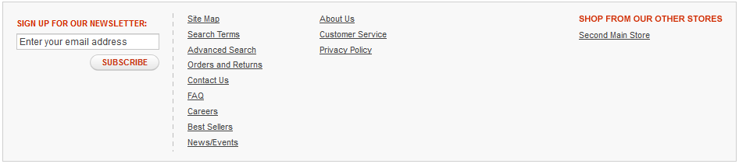
Figure 5-1

Post Installation, the module can be seen at the Zeon Extensions->FAQwithin the Admin panel [Refer Figure 5-2]

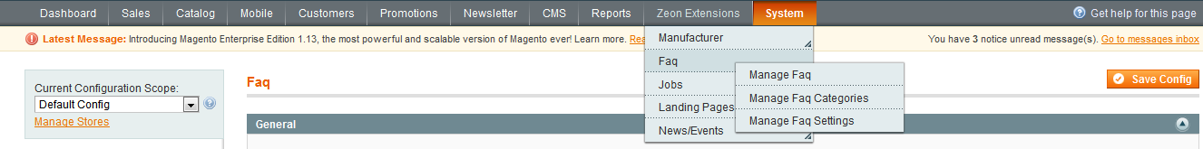
Figure 5-2

Manual Installation

Note: Please place all the files and folders as specified below to get the extension working.

- Obtain a copy of the FAQ ModuleUnzip the Module files into a local directory.
- Move all files into their respective directories in your Magento installation directory on the FTP server as they appear after unzipping the package.
- Clear your store cache.
- In your Magento admin panel, this is under System > Cache Management.
- Log Out of your Magento Admin and then log back in.
- This refreshes the Magento ACL date which effects your administrative permissions. You will not see expected module behavior until you do this. You may also need to refresh your cache.
- After all copying is complete browse to your Magento homepage in order to complete the module install
- You should now have a “General” and “Frontend” section in your Admin Panel under System>Configurations> -> (Under ZEONE EXTENSIONS Tab) ->Faq

Further details are given in the configuration section

Configuration

All configurations are handled in the MagentoAdmin Panel. After successful installation, login to your store admin panel and check the configuration as suggested below:

Zeon Extensions ->Faq-> Manage Faq SettingsOR System ->Configuration-> (Under ZEONE EXTENSIONS Tab) ->Faq
[Refer Figure 6-1]

First tab that follows is General with the setting i.e. Enable. This setting turns the whole Module on or off [Enable/Disable]

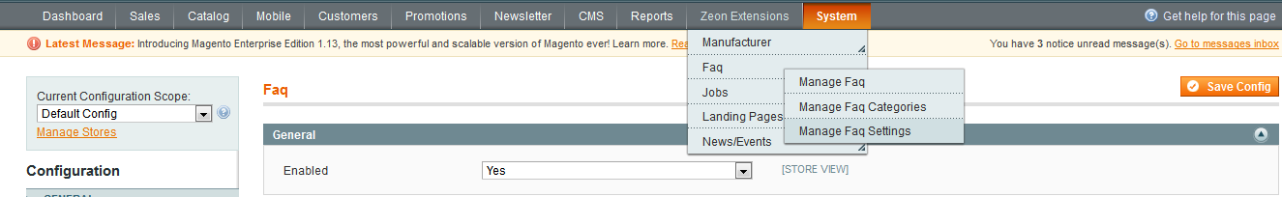

Figure 6-1

Clicking on the second section i.e. Front End gets the settings to manage the front end appearance of the extension

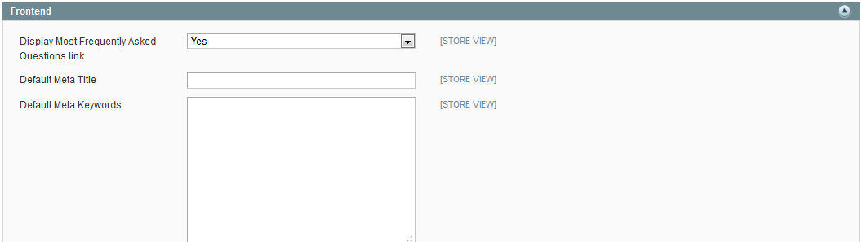
Figure 6-2

- You can specify whether to display the Most Frequently Asked Questionslink on Frontend or not by selecting yes or nooption from the Enabled drop down [Refer figure 6-3]
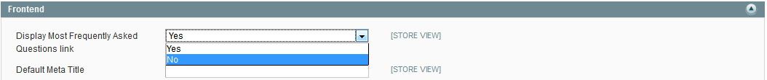

Figure 6-3

Adding Category
FAQ category can be added by clicking Add Category button at the top right corner of the page [refer Figure 6-4]
This is the FAQ Listing page hence a created category can also be Edited
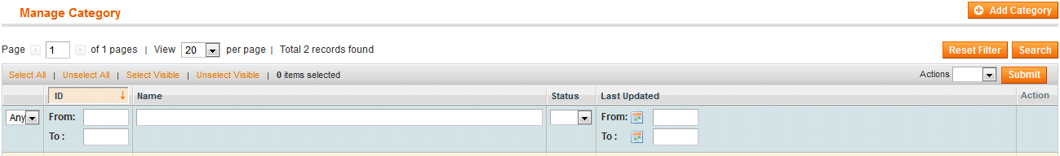
Figure 6-4
Name, Identifier, Status [Enabled/Disabled] and sort order inputs required to create a category.
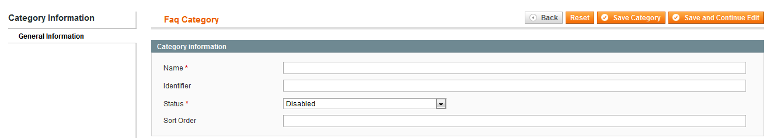
Figure 6-5

Adding a FAQ
Zeon Extensions->FAQ->Manage FAQ
To a add an FAQ, above to be navigated and user need to click on Add FAQ [Refer Figure 6-6]

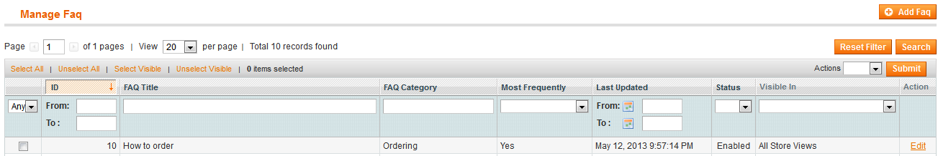
Figure 6-6

The subsequent page gets the fields to be populated by the user to add the FAQ
[Refer Figure 6-7]
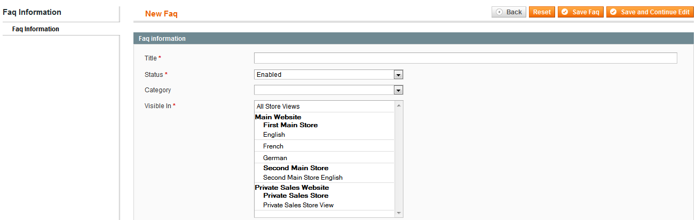
Figure 6-7

Front End
All the Frequently asked questions categories and the questions along with the Most Frequently asked can be found at the front end.
It has a nice and organized Table of Content which makes the on page navigation quick.
This module is also equipped with the FAQ search functionality which really makes the search easy.
Top left corner of the page lists all the categories and selection brings the respective FAQ’s

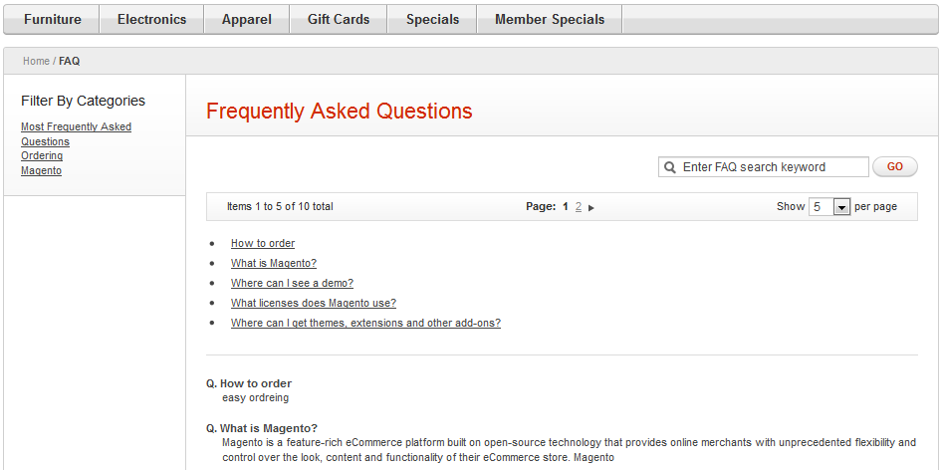
Figure 6-8

Technical Information

Components:

The FAQ module has the following components:

- Controllers: The FAQ Module doesn’t override any core controller functionality.
- Models: The Model contains files having function to save the FAQ information in the database as well as display this information on backend (Admin) and Frontend.
- Frontend: This module has three template files located in the path: /app/design/frontend/base/default/template/zeon/faqthis files showsthelist of FAQ in the Front end also user can list the FAQs by Categories and MFAQ(Most Frequently Asked Question).
- Database Tables: The FAQ Module create three tables zeon_faq,zeon_faq_categoryand zeon_faq_storeto store the FAQ information.

Un-installation
Below are the steps to un-install the application
- If you install the FAQ module using magento connect you can uninstall this by using the Magento Connect Manager
- If you have installed the FAQ module manually by copying the files and placing them in the mentioned directories you can also un-install this module by simply deleting the files form the directories where you copied them.
- After Un-installation refresh cache from admin panel or delete that from file system /var/cache.
- Remove design files from below folders
- \app\design\frontend\base\default\template\zeon\ faq(remove all the files from this directory)
- \app\design\frontend\base\default\layout\zeon\ faq.xml
- \ app\design\adminhtml\default\default\layout\zeon\ faq.xml
- Remove “Zeon_Faq .xml” from \app\etc\modules\ folder
- Remove Module from Code
- Remove files form “app\code\local\Zeon\Faq” (remove all the files from this directory)
- Remove Locale file
- Remove “\app\locale\en_US\ Zeon_Faq.csv”
Remove Database tables [Run below queries in database]

- DROP TABLE `<prefix>zeon_faq_store`
- DROP TABLE `<prefix>zeon_faq_category`
- DROP TABLE ` <prefix>zeon_faq`
- DELETE FROM `<prefix>core_resource` WHERE <prefix>core_resource.code = ‘zeon_faq_setup’

Unsupported Features & Known Issues

- For Magento EE 1.10v the sample data is not get stored in the database since this version does not support the data install script which is responsible for the sample data insertion in the database.
- To install the sample data so that user get some idea of how this extension works you have to import the data in to your database using the faq-data-install.sql file provided with the package you can do this using any database manager software like your PhpMyAdmin or SQLyog etc.

Troubleshooting
- If you install the FAQ module using magento connects and you are facing any issue check the version of your magneto installation and whether it is compatible with this module or not.
- If you have installed the FAQ module manually by copying the files and placing them in the mentioned directories check that you have copied all the files to their desired directories and follow all the steps mentioned in the installation.
- Before reporting an issue please first refresh cache from admin panel or delete that from file system /var/cache and reload your site.
It is highly recommended to back up your server files and database before installing the module.

